Name: **ZOHAIB HASSAN SOOMRO**

RollNo#: **19SW42**

Subject:  **DBS**

**The Flight Database stores details about an airline's flights and seat bookings. Consider the Following requirement List:**

* The airline has one or more airplanes.
* An airplane has a model number, a unique registration number, and the capacity.
* An airplane flight has a unique flight number, a departure airport, a destination airport, a departure date and time and an arrival date and time.
* Each flight is carried out by a single airplane.
* A passenger has given a name, a surname and a unique email address.
* A passenger can book one or more seats on a flight.
* **For above mentioned case study**

**1. Identify the Entities.**

**2. Specify the attributes for each of the entity.**

**3. Specify the relationship among entities.**

* **Draw the Conceptual Model, Logical Model and Physical Model.**
* **Answers:**

1. **Identify the Entities:**

**Ans:**

* + Airline
  + Airplane
  + Flight
  + Passenger
  + Seat

1. **Specify the attributes for each of the entity:**

**Ans:**

* + **Airline** 
    - Attributes: None
  + **Airplane**
    - Attributes: modelNumber, registrationNumber(primary key), and capacity.
  + **Flight**
    - Attributes: flightNumber(primary key), departureAirport, destinationAirport, departureDate, departureTime, arrivalDate and arrivalTime.
  + **Passenger**
    - Attributes: name, surname and emailAddress(primary key).
  + **Seat**
    - Attributes: None

1. **Specify the relationship among entities:**

**Ans:**

* + Airline:
    - Airline has one to many relationship(1:N) with Airplane entity.
  + Airplane
    - Airplane has many to one relationship(N:1) with Airline entity.
    - Airplane has one to one relationship(1:1) with Flight entity.
  + Flight
    - Flight has one to one relationship(1:1) with Airplane entity.
  + Passenger
    - Passenger has 1 to many relationship(1:N) with Seat entity.
  + Seat
    - Seat has many to 1 relationship(N:1) with Passenger entity.

1. **Draw the Conceptual Model, Logical Model and Physical Model:**

**Ans:**

* 1. **Conceptual Model:**

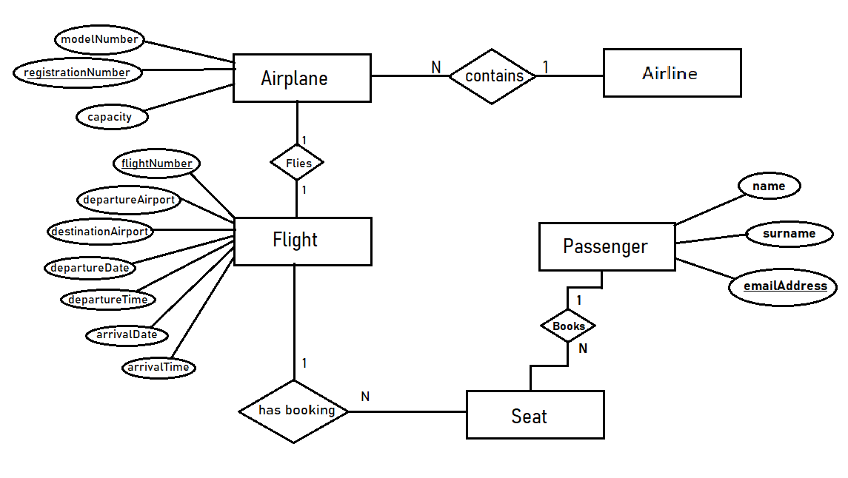

* 1. **Logical Model:**

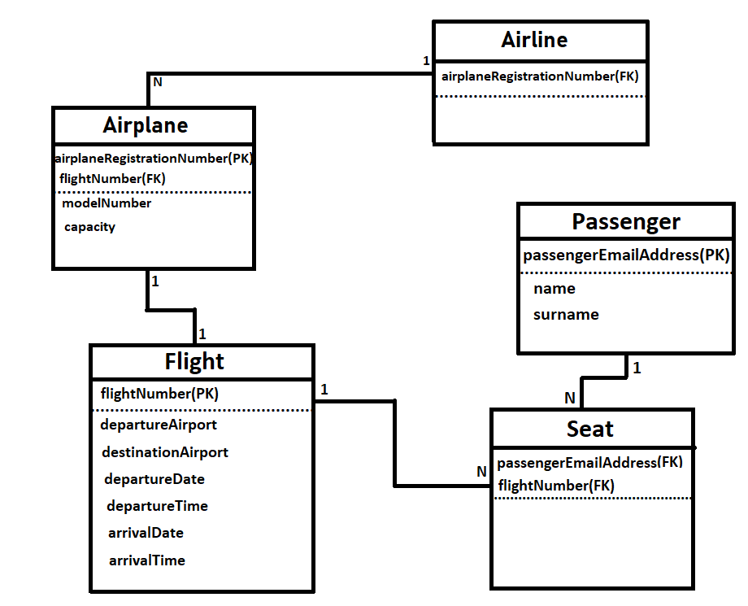

* 1. **Physical Model:**

